**Documentation of ShowBridge API**

This is the backend approach to implement the CRUD operations of inventory items for organization ADMIN.

How to use the run API:-

1. Get the code from Github.
2. Open in your VS.
3. Build the solution.
4. Run the solution.
5. You may get the SSL certificate permissions Popup, please allow.

After Solution starts running, Swagger UI will appear on the browser tab.

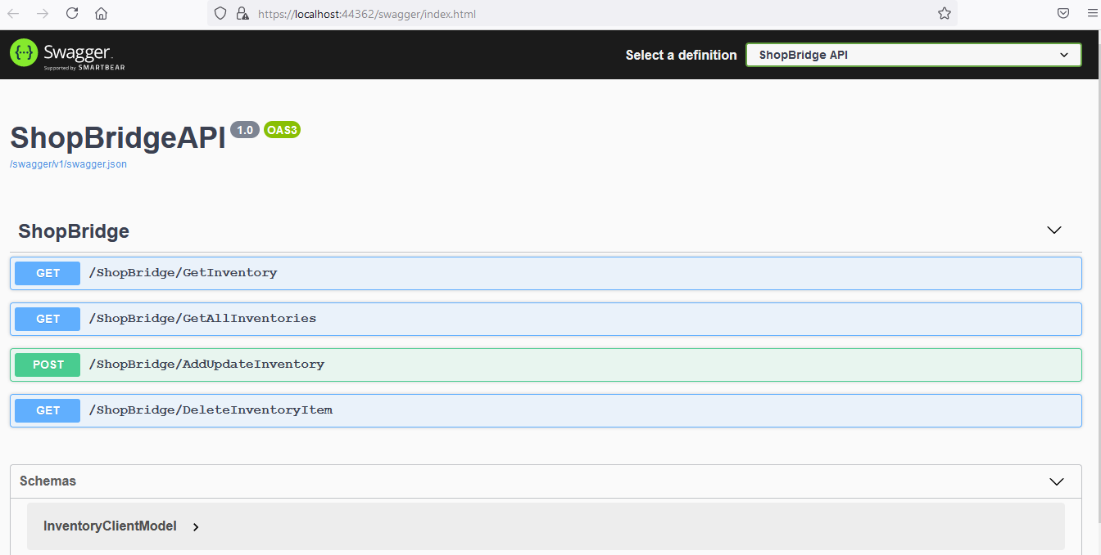

There are 4 methods present:-

1. GetInventory:- Used get the inventory details based on ‘InventoryId’.
2. GetAllInventories:- This method gets all the inventory items for the Database which are not deleted.
3. AddUpdateInventory:- This method used to Save new inventory and update existing inventory.
4. DeleteInventoryItem:- This method is used to delete the inventory from database.(soft delete)

**GetInventory:-** Click on Getiventory method and try it out.

Pass the parameter.

Click on execute.

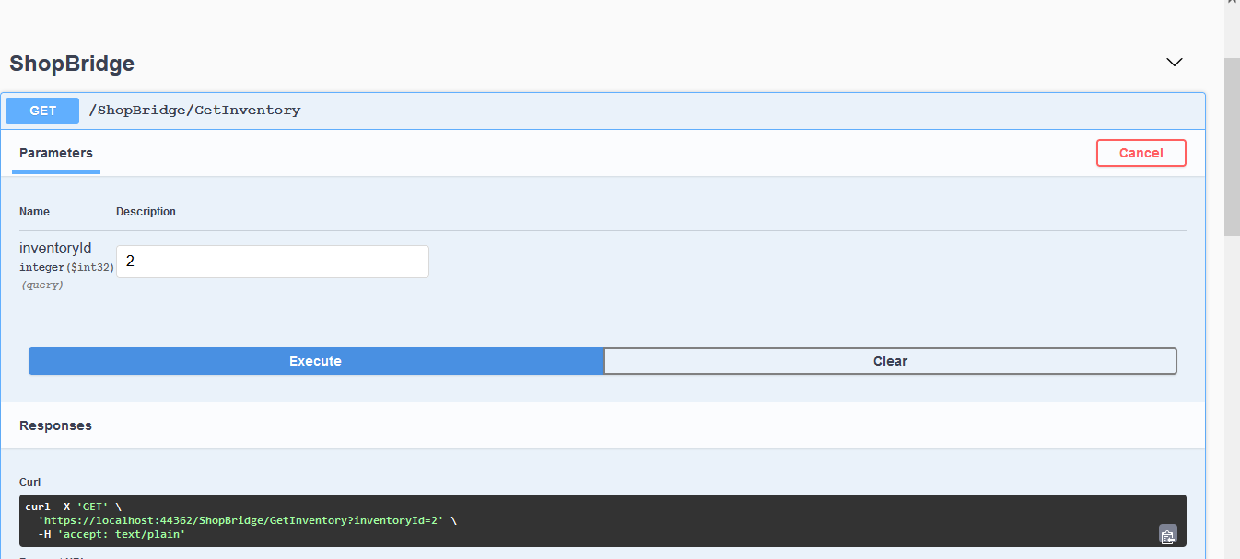

Result:-

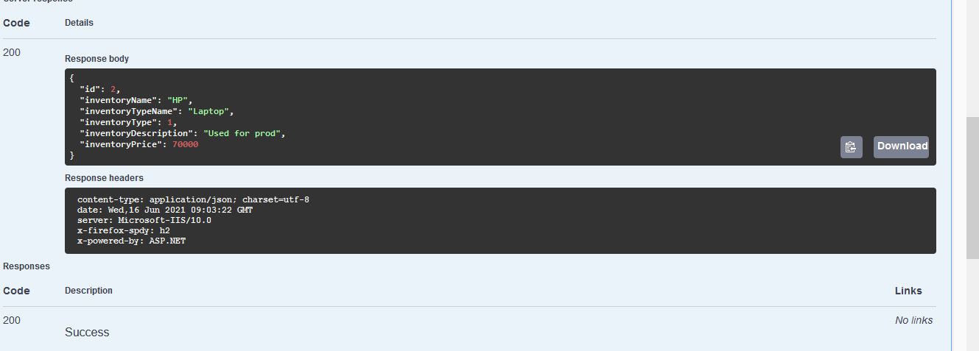

Similary, We can check the working of other methods.

**Time Consumption**

**Database Design**:- Database name ‘ShopBridge’.

This consists of two tables:-

1. Inventory
2. lkpInventoryType

Inventory:- This table stores the details of inventory like price,description etc.

lkpInventoryTypes:- This is the lookup table stores the inventory type like Laptop,PC,Mouse etc.

This takes approx 15 minutes.

**WebAPI**:-

Integrating DB:- It takes approx 10 min while scaffolding the DbContext and including the tables from database.

Implementing Repository:- It takes approx 30 mins as i had created ‘BaseRepository’ and ‘UnitOfWork’ which includes all the generic methods for Modifying,adding, retrieving enities.

Other Coding Logic:- I had implemented swagger UI so that check my request and results. And logics are suppose to be implement in ‘ShopBridgeService’ which is called from ‘ShopBridgecontroller’.

This takes approx 50 mins.